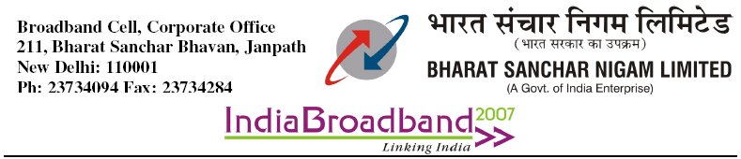
No: 64-17/09-Broadband Dt 12-05-09
To
All Heads of Circles/Metro Districts.
(Except Kolkatta Telephones)
Sub: Corrigendum No-1 to agreement for provision of wire line BB connectivity in rural & remote areas-agreement No.30-160-8/Wireline-BB/2006-USF dt 20-01-2009
Ref: This office Lr.No:64-17/09-Broadband dt 2-2-09

With reference to the above subject, the undersigned is directed to forward herewith a copy of letter No.30-160-8/Wireline_BB/2006-USF(Vol-II) dt 27-03-09 received from Director(BB), USOF, for claiming subsidy under USOF for giving Wireline Broadband connectivity in rural & remote area.
All circles are requested to follow the revised annexures given in the letter, while claiming subsidy from USOF.

Enc: as above

Sd-
(M.S.T.Sundari)
AGM(BSP)

Department of Telecommunications
Sanchar Bhavan, New Delhi-110001
USOF Section

No.30-160-8/Wirline_BB/2006-USF (Vol. II) Dated: 27.03.2009

Sub: Corrigendum No. 1 to Agreement for Provision of Wire-line Broadband Connectivity in Rural and Remote Areas, signed with BSNL (Agreement No. 30-160-8 /WIRELINE-BB/2006-USF Dated 20/01/2009)

1. Background: An Agreement has been signed between USO Fund and BSNL on 20.01.2009 for provision of Wire-line Broadband Connectivity in Rural and Remote Areas. The Attachments to Annexure- I have been slightly modified for more clarity and to rectify the typographical errors.

2. Modifications: The following modifications have been made to the Attachments

2.1 Attachment- 1/6:

i) In Col. 14, the words “Col. 7 Attachment 6/6* Rs. 4500/- may be read as “Col. 10 Attachment 6/6 * Rs. 4500-“.
ii) The Rows “Total for exchange XXX” and “Total for exchange YYY” may be deleted.
iii) In Col. 4, the three entries of “X”, “X” and “X” may be changed to “X”, “Y” and “Z”. The three rows containing entries “Y” are to be deleted.
iv) The words “QE” are to be added at the top of the Attachment.
v) In Note-4, the total number of computing devices may be changed to 31 per exchange instead of 32 per exchange.

2.2 Attachment- 2/6:

i) In Note-1, in the bracket, the words “...clause 14.5 of the Agreement” may be read as “... clause 14.6 of the Agreement”.
ii) In Col. 17, the words “... days of existence (Col. 15)...” may be read as “...days of existence (Col. 16).
iii) In Note-7, the words, “(Date format in column No. 10, 11, 12 and 15...)’ may be replaced with,” (Date format in column No. 11, 12, 13 and 15...)’.

2.3 Attachment- 3/6:

i) In Note-1, the words, “...refer to Clause 14.4 and 14.5” may be read as, “...refer to Clause 14.5 and 14.6”.
ii) In Note-3, the words, “(...for the actual duration for which the BB connection...)” may be replaced with, ““(...for the actual duration for which the Kiosk...)”.

2.4 Attachment- 4/6:
i) Firstly, the totals are to be struck exchange-wise. One additional row “TOTAL OF ALL NEW CONNECTIONS (WITH COMPUTERS AND WITHOUT COMPUTERS)” may be added.
ii) In Column 12, the words “(refer Clause 14.6 of the agreement)” may be read as “(refer to Clause 14.6 and 14.7 of the Agreement)”.

2.5 Attachment- 5/6:
i) The format has been renamed and redesigned. This format will be a summary of all the closed connections.

2.6 Attachment- 6/6:

i) The words “QE” may be added at the top of the Attachment.
ii) In Col 6, the words “(C of attachment 5/6) may be changed to “(From
Attachment 5/6)”
iii) The footnote “Copy of First Bill to be appended for every new
Kiosk added during the Quarter” may be deleted.
iv) Notes from serial No. 1 to 3, may be added

2.7 A copy of the modified Attachments, as detailed above, are enclosed herewith.

(Arun Agarwal)
Director (BB) USOF

Copy to:

i) GM (Broadband), BSNL Corporate Office, New Delhi, w.r.t. the Agreement for Provision of Wire-line Broadband Connectivity in Rural and Remote Areas, signed between USOF and BSNL (Agreement No. 30-160-8 /WIRELINE-BB/2006-USF Dated 20/01/2009).

ii) JA (F) USOF, w.r.t. their office communication No. 30-44/USOF-BB (LL) Scheme dated 10.02.2009.

